
New visitor’s registration for parents & guardians at Tiffin Girls School
Dear parents and guardians,
All our “on-pitch” registration is done online, but we have used paper registers until now to register your attendance as visitors at Tiffin Girls School for the training and games of the junior teams.
From Sunday onwards we would like to go online with the app Loveadmin.com is providing. As a parent/guardian you already have a log in for the system and will be able to use the app straight away.
You might have seen the QR code from Tiffin School dotted around the school premises which is linked to the NHS Test & Trace app and we advise you to use this as an additional option if you can, but you will need to register your attendance with the club to be able to stay during the training or game time.
As a parent or guardian of a club member you can register here from Monday to Sunday each week for the upcoming Sunday. If you have any problems, please contact Deborah at junioradministrator@okhockey.com.
Download the app “LoveSport”

Log in with your Loveadmin.com username & password
Go to EVENTS
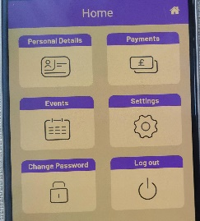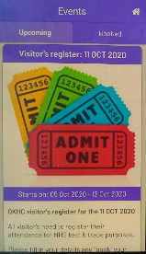
Scroll down and tap “view details” and choose the training or game you will attend as a visitor, scroll down and tap NEXT
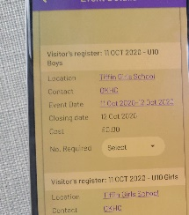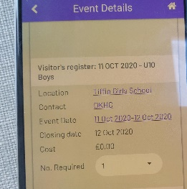
Either choose your name from the dropdown box which will populate your details or tap CLEAR and add your details, then tap SAVE
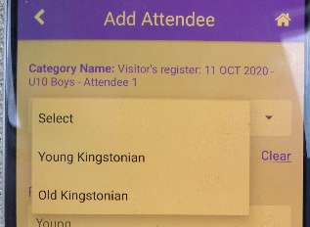
Tap the HOME key at the top right corner when the payment question appears (obviously no costs involved 😊)
ALL DONE
You will receive a confirmation of your registration by email.

